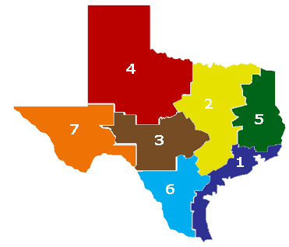 TEXAS ECOREGION BROCHURE PROJECT
TEKS 7.8B - Analyze the effects of weathering, erosion, and deposition on the environment in eco-regions of Texas
DIRECTIONS:
You will work individually to create a tri-fold brochure about weathering, erosion and deposition in a specific ecoregion of Texas. Use reference materials (ex. handouts, workbook & internet) to investigate the features of your eco-region.

The following should be addressed in your brochure:
- NATURAL PROCESSES THAT CAUSE CHANGE: What evidence of weathering, erosion, and/or deposition exists in that area? **Give examples using landforms.

- HUMAN ACTIVITIES THAT CAUSE CHANGE: How have humans impacted your area? (positive and/or negative) **Give examples

- CHARACTERISTICS OF YOUR ECO REGION: List the plants and animals that live in your assigned eco-region, include altitude, average temperatures (climate)

- INTERESTING FACTS: Use this to show how unique your ecoregion is, you can find the importance of this eco-region, why this specific area is affected by weathering, erosion and/or deposition, what attractions draw visitors to this area.

Your grade will be based on the following criteria:
- Each brochure “informational flap” (4) is worth 20 points…80 pts total
  - Provide solid information, easy to read, appealing to audience

- Front of brochure with Travel Agency name – 5pts
  - Unique to student, Logo

- Use of Various Colors & eye catching pictures - 15 points
Total 100 points…bonus points can be earned!

THIS PROJECT IS DUE NO LATER THAN APRIL 9, 2015.

